**Organic acids:**

Organic acids are commercially prepared using fungi. Rhizopus is one of the fungi that are used to ferment substrates such as fruits and sugar-containing syrups. Examples of [acids](https://www.toppr.com/guides/chemistry/acids-bases-and-salts/introduction-to-acids/) that are derived and manufactured on a large scale using fungi are acetic acid, citric acid, gluconic acid, fumaric acid and lactic acid.

Rhizopus stolonifer is a fast growing parasite that is selfish and absorbs all of the nutrients of the substrate, leaving it with nothing to live on.

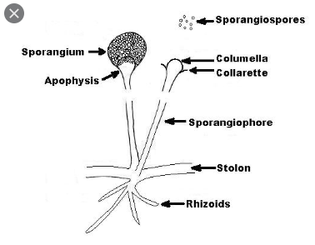

***Penicillium***

Antibiotics are substances produced by microorganisms that kill or inhibit other microbes which are used in the treatment of infectious disease. Antibiotics are produced in nature by molds such as Penicillium and bacteria such as Streptomyces and Bacillus.

Since **Penicillium** molds can cause food spoilage, they also present a health hazard when consumed. This is because some species of **Penicillium** produce **toxic** compounds known as mycotoxins. (9) These toxins make food inedible and **dangerous**

***E.coli***in insulin production and vitamins.

Some types of e coli can cause illness in humans, including [diarrhea](https://www.medicalnewstoday.com/articles/158634.php), abdominal pain, [fever](https://www.medicalnewstoday.com/articles/168266.php), and sometimes vomiting.

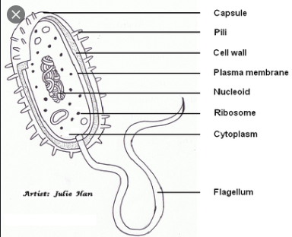

Streptomyces

Antibiotics are substances produced by microorganisms that kill or inhibit other microbes which are used in the treatment of infectious disease. Antibiotics are produced in nature by molds such as Penicillium and bacteria such as Streptomyces and Bacillus.

Streptomyces are infrequent [pathogens](https://en.wikipedia.org/wiki/Pathogens), though infections in humans, such as [mycetoma](https://en.wikipedia.org/wiki/Eumycetoma), can be caused by it.

